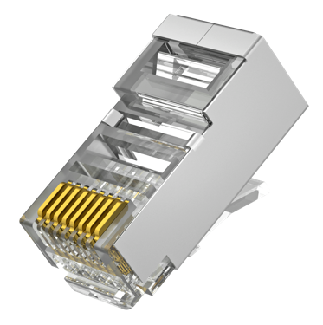
Cat 5e Shield Modular RJ45 Connector
3U Gold-Plated Contacts

Model: RJ45-5ES

Main Features:
- Durable design: ≥ 1250 mating cycles;
- Trident head ensures stable contact for rapid transmission;
- 3μin gold-plated contacts for optimized signal integrity.

Connector Type
Category | Cat 5e
Type | 8P8C (Eight Position, Eight Contact)
Shielding | Shielded
Material
Housing Material | Polycarbonate
Shielding Material | Brass with nickel plating
Contact Material | Copper
Contact Surface Material | Gold Plating on Nickel Barrier
Gold Plating Thickness | 3U (3μin or 0.0762 µm)
Electrical Properties
Voltage/Current Rating | 125 VAC / 1.5 A
Insulation Resistance | ≥ 500 MΩ
Contact Resistance | ≤ 20 mΩ
Dielectric Withstand Voltage | 1500 V DC/AC Peak
Mechanical Properties
Durability | ≥ 1250 mating cycles
Wire Gauge | 0.85 mm ≤ Ø ≤ 1.1 mm
Environment
Operating Temperature | -40°C to 70°C
Operating Humidity | RH 10% to 90% (non-condensing)
Storage Temperature | -40°C to 80°C
Storage Humidity | RH 5% to 96% (non-condensing)
General
Dimension | 23x12x8 mm (LxWxH)
Net Weight | 2.2 g
Diagram
